 | E-learning Management(132)  Technical Design Document
 | Prepared By / Last Updated By | Reviewed By | Approved By
Name | Vikrant Daptardar & Utkarsh Shrivastava
Role | Team members
Signature
Date | 10/12/2019

Table of Contents

1.0 Introduction 3
1.1 Purpose of this document 3
1.2 Project overview 3
2.0 Solution Summary 3
2.1 Scope 3
2.2 Assumptions 3
2.3 Dependencies 3
2.4 Risks 3
3.0 Schematic Diagram 3
4.0 System Design 4
4.1 Proposed design 4
4.2 Component inventory 4
5.0 Database Design 4
5.1 Data Model 4
5.2 Tables Structure 4
6.0 Appendices 4
6.1 Glossary 4
6.2 Other 5
7.0 Terms & Conditions 5
8.0 Change Log 5

Introduction

Purpose of this document
The purpose of this document is to document the technical design, component details and Database design. This will also capture the scope, assumptions, risk, dependencies of this project.

Project overview
E-learn is a portal for the learner to learn new technologies in many modes of services like online ,offline and private tuitions offered by various vendors and an admin member who overviews the efficient working of the above

Solution Summary

Scope
Our project’s scope includes three services online learning, offline classroom programs and private tuitions .The vendor can add or modify courses against any of these services as per their choice .The user can view various courses offered by various vendors against these services and can subscribe for any of those courses.

Assumptions
We assume the following while development of our project:
- There are multiple admins.
- There can be multiple vendors
- There can be multiple users/subscribers

Dependencies
There are no dependencies related to our project the technologies we used in our project are the ones we were trained on.

Risks
None as of now.

Schematic Diagram
Vendor home:
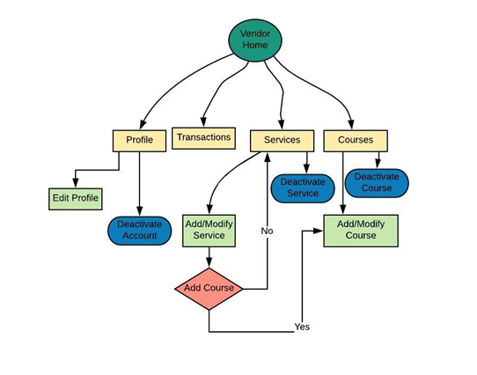

License management:

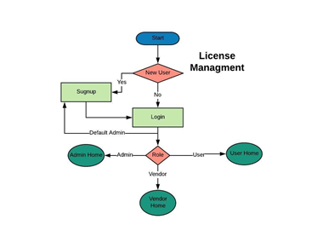

User home:
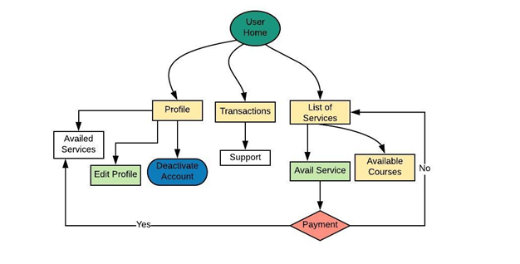

Admin home:

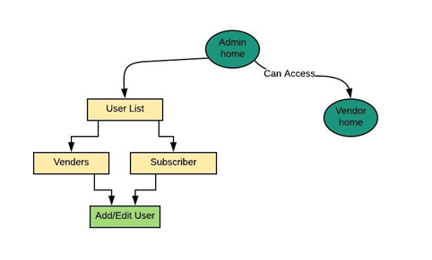

System Design

Proposed design
Below are the design objectives that shall be fulfilled post the execution of this project:
- Role based registration & credential authentication
- Listing the services on database
- Availing the service
- Generation of bill
- Obtaining vendor/subscriber information
- Accessing the courses based on subscribed services

Component inventory
High level component breakdown:
- User component
- Admin component
- Login/signup component
- Vendor component

Database Design

Data Model
<This sub section will give the schematic view of the database design>
Database includes various tables and their interdependencies with one another which can be seen in the below table structure.
The tables include:
- User table: Includes name ,age ,gender and other relevant details of the user
- Role table: Includes name of the role and code of the role which is the primary key of the table
- Address table: : Includes address lines ,pin-codes and other relevant details of the user
- Service table: Includes name of service, code, duration and amount that is the cost of the service
- Course table: Includes the course name and code of the course.
- Service course table: It shows the number of courses residing against various kind of services
- User service table: It shows the details about the various services opted by different users

vendor
User list
ContactNumber
Password
Avail service
profile
transactions
support
Contact Number
Number
Password
Avail service
transactions
Password
Deactivate account
profile
Viewed
By

ADMIN
vendor
User
Can access
subscriber
Add/edit user
List of services

Model structure

Tables Structure
Table name: address
Primary key: adderss_id
Foreign key: -

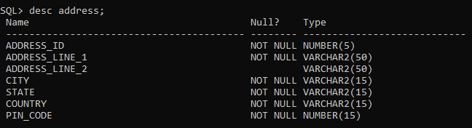
Table name: course
Primary key: course_code
Foreign key: course_user_id
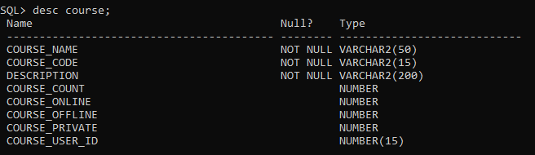

Table name: elearning_user
Primary key: user_id
Foreign key: user_address

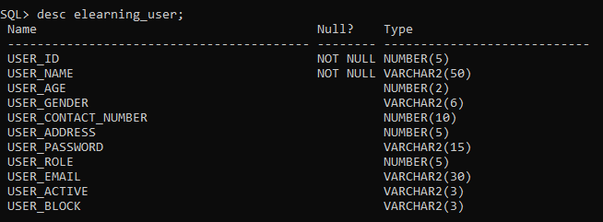

Table name: offline_course
Primary key: offline_course_id
Foreign key: offline_course_code

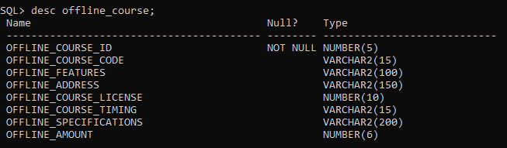

Table name: online_course
Primary key: online_course_id
Foreign key: online_course_code

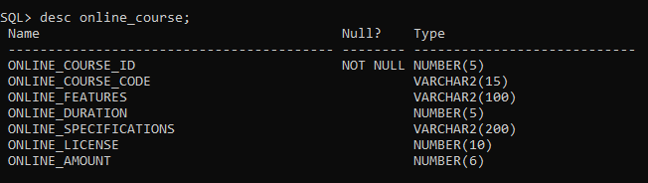

Table name: private_tutions
Primary key: private_id
Foreign key: private_course_code
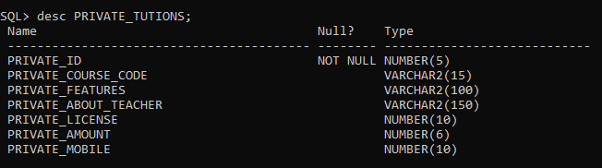

Table name: role
Primary key: role_id
Foreign key: -
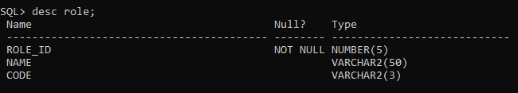

Table name: service
Primary key: service_code
Foreign key: service_user_id
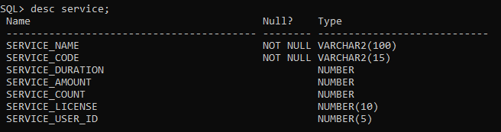

Table name: service_course
Primary key: service_course_user
Foreign key: service_course_service
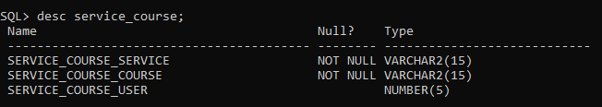

Table name: service_type
Primary key: service_type_id
Foreign key: -
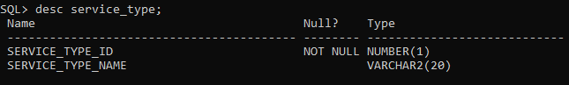

Table name: user_course_subscription
Primary key: course_type_id
Foreign key: user_id
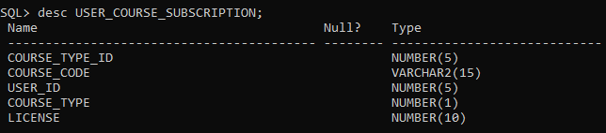
Table name: user_service
Primary key: user_service_user
Foreign key: -
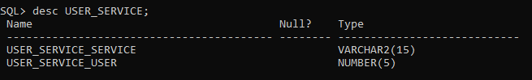

Appendices

Glossary
Acronyms | Definitions
null | null

Other

Terms & Conditions
Interns shall be solely responsible for all its acts and omissions under this program. Interns will comply at all times with all applicable laws. Interns shall not use Cognizant’s name, logo and trademark in any promotional materials or other communications with third parties without the prior written consent of Cognizant. Any materials used by interns in relation to program will not infringe the copyrights, trademarks, patents, trade secrets or other intellectual property rights, privacy or similar rights of any person or entity. Interns agrees not to post, draw, make, display any content that is threatening, libelous, obscene, defamatory, abusive, pornographic, or advocates/encourages any conduct that could constitute a criminal offence or give rise to any civil liability. Cognizant its associates’ personal details including but not limited to name, address, contact number shall not be shared or forwarded to any third party, without prior written consent of Cognizant, its associates. All intellectual property provided by Cognizant, as part of program shall be owned exclusively by Cognizant. Intern shall indemnify, defend and indemnify Cognizant its associates, officers, directors from and against any claims, demands, loss, damage, liability, causes of action, judgments, or costs and expenses of every nature (including attorney’s fees and expenses) incurred by Cognizant based on any claim that any breach of terms and conditions of this program

Change Log
Please note that this table needs to be maintained even if a Configuration Management tool is used.
Version Number | Changes made
V<n.n> | <If the change details are not explicitly documented in the table below, reference should be provided here>
V<n.n> | Page no | Changed by | Effective date | Changes effected
V<n.n> | 1-11 | Vikrant Daptardar & Utkarsh Shrivastava | 10/12/2019 | First update
V<n.n> | 1-16 | Vikrant daptardar | 10/24/2019 | Final update

